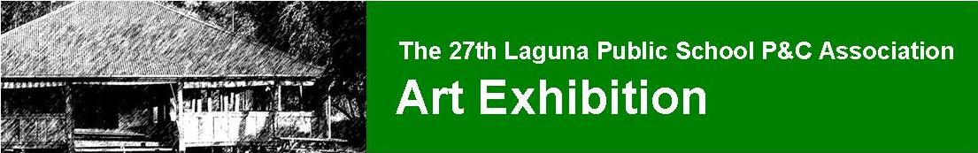

LAGUNA PARENT’S AND CITIZEN’S ASSOCIATION

invite you to participate in the 2018 Art Exhibition
SOCIAL MEDIA PROMOTION
This year as part of our promotion for the Annual Art Exhibition, we are planning to promote the artists on social media.
These will consist of a short biography of the artist, a photo, a video and a website or social media link, and will be posted on the official Facebook page: https://www.facebook.com/LagunaArtShow.
These will be an exciting addition to the page, and the opportunity to be featured is open to all exhibiting artists.
If you would like to participate, please fill in the following details and return with your Entry Form by Friday 29th June 2018. This is a month earlier than the regular entry form requirements, allowing us almost two months of social media coverage for the artists involved. (Forms received later than this cannot be guaranteed a promotion – they will be done in order of receipt.) To assist us in the production of this, if you could supply all or either one landscape and one portrait image, no longer that 1MB each, and a short video.
Surname: | Given Name:
Website:
Facebook:
Instagram:
Biography (incl. inspirations, medium/s, etc – 25 to 50 words):

What excites you about being involved in the Laguna Art Show? / Can you give us a brief explanation of what the public should expect from your entry this year? (Optional – max 20 words.)

If you have any queries about this new facet of the Art Exhibition promotion please contact co-coordinator Natalie Moore at lagunapncartshow@gmail.com with the subject line Social Media Featurettes.
We are looking forward to another exciting Art Exhibition and thank you for your ongoing participation in this school fundraiser.
Art Exhibition 2018 Coordinators
Natalie Moore & Milly Ablett

