Pentatonic Scale

e|----------------------3-6-------------------------|
B|------------------3-6-----------------------------|
G|--------------3-5---------------------------------|
D|----------3-5-------------------------------------|
A|------3-5-----------------------------------------|
E|--3-6---------------------------------------------|

Pentatonic Scale, from Root Note G
Pattern is always the same, just the root note changes.
Practice going up, then practice going down.
Choose different starting points – identify the root note first.
Don’t rush – concentrate on being slow and smooth.

Root Notes on the E (6th) String
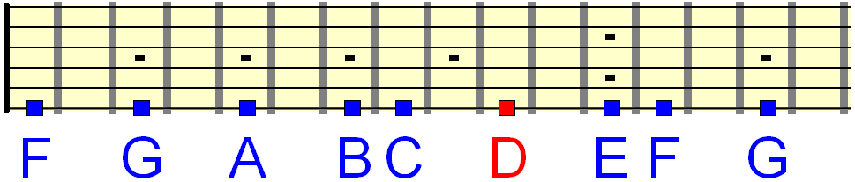

Practice the scale from each of these notes!

